Answer to the question no 5
(b)
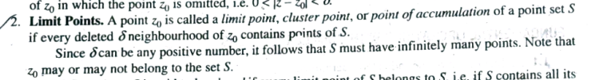
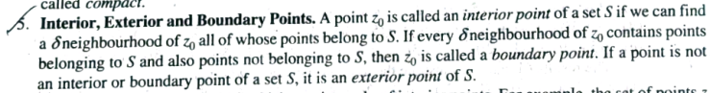
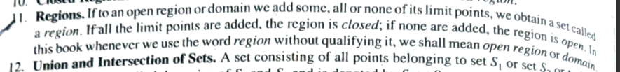

Answer to the question no 6
(b)
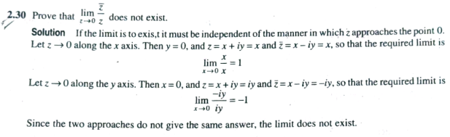
(c)
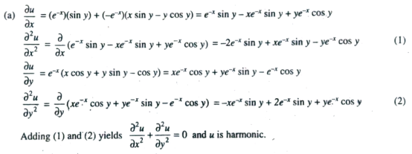

Answer to the question no 7
(b)
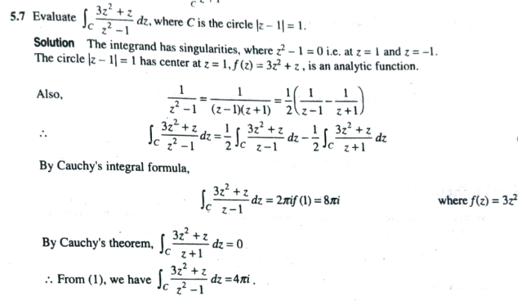
(c)
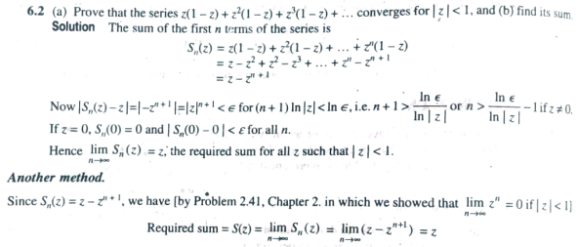

Answer to the question no 8
(a)
